Match the photo of the city to the correct country.

1. 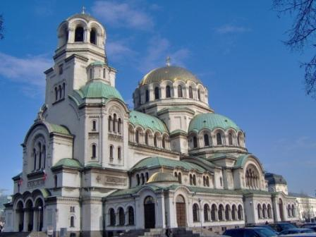 Cathedral of St Alexander Nevsky, Sofia
   1. Italy
   2. Romania
   3. Spain
   4. Bulgaria

Answer: d

1. 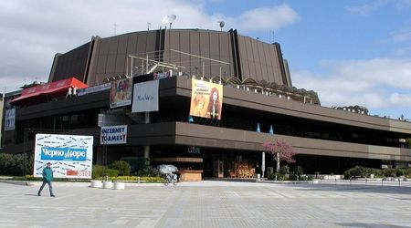 Festival And Congress Centre, Varna
   1. Poland
   2. Bulgaria
   3. Turkey
   4. Italy

Answer: b

1. 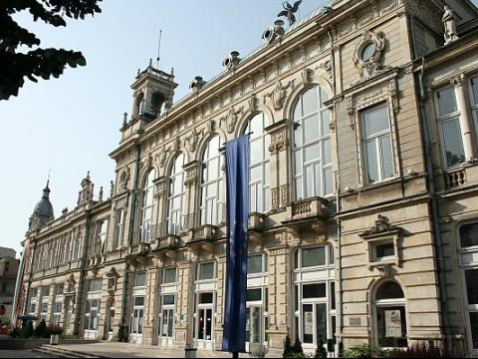 Rouse Theatre
   1. Sweden
   2. Italy
   3. Spain
   4. Bulgaria

Answer: d

1. 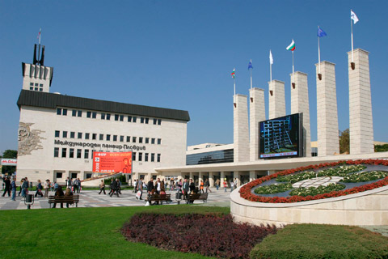 International Fair, Plovdiv
2. Bulgaria
3. Turkey
4. Poland
5. Sweden

Answer: a

1. 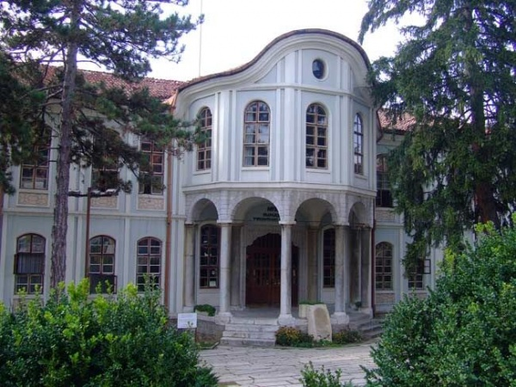 Museum of the Revival and Constituent Assembly, Veliko Tarnovo
   1. Poland
   2. Bulgaria
   3. Spain
   4. Italy

Answer: b

**Sources:**

**Cathedral of St Alexander Nevsky, Sofia:**

<http://bg.wikipedia.org/wiki/%D0%A5%D1%80%D0%B0%D0%BC-%D0%BF%D0%B0%D0%BC%D0%B5%D1%82%D0%BD%D0%B8%D0%BA_%E2%80%9E%D0%A1%D0%B2%D0%B5%D1%82%D0%B8_%D0%90%D0%BB%D0%B5%D0%BA%D1%81%D0%B0%D0%BD%D0%B4%D1%8A%D1%80_%D0%9D%D0%B5%D0%B2%D1%81%D0%BA%D0%B8%E2%80%9C>

**Festival And Congress Centre – Varna:**

<http://bg.wikipedia.org/wiki/%D0%A4%D0%B5%D1%81%D1%82%D0%B8%D0%B2%D0%B0%D0%BB%D0%B5%D0%BD_%D0%B8_%D0%BA%D0%BE%D0%BD%D0%B3%D1%80%D0%B5%D1%81%D0%B5%D0%BD_%D1%86%D0%B5%D0%BD%D1%82%D1%8A%D1%80>

**Rouse Theatre:**

<http://www.theatre.ruse.bg/>

**International Fair, Plovdiv:**

<http://www.fair.bg/>

**Museum of the Revival and Constituent Assembly, Veliko Tarnovo:**

<http://veliko-tarnovo.net/english/museum-of-the-bulgarian-revival-and-constituent-assembly.html>